# Flower, Mango leaf and Papaya leaf Detection

##### **Iftekhar Jamil, Ibrahim Khalil, Tulshi Chandra Das**

Institute of Information Technology, University of Dhaka

***Abstract*-** Classification of objects by image processing is an important field of machine learning. Our objective is to identify correct class of flower, papaya leaf and mango leaf of a given input image. We took about 100 images of each class to prepare our model. We used Convolutional Neural Network learning approach to create our model. Our model gives 60% accuracy at testing set.

***Index Terms***- classification, flower, mango leaf, papaya, CNN.

1. Introduction

c

onvolutional networks are simply neural networks that use convolution in place of general matrix multiplication in at least one of their layers. [1] They have applications in image and video recognition, recommendation systems, [2] image classifications, medical image analysis and natural language processing. [3] In our image processing classification, we use CNN approach to reduce the processing cost. Convolutional networks were inspired by biological processes [4] [5][6] [7] in that the connectivity pattern between neurons resembles the organization of the animal visual cortex. Individual cortical neurons respond to stimuli only in a restricted region of the visual field known as the receptive field. The input and a output layer, as well as several protected layers, are part of a convolutionary neural network. The hidden layers of a CNN typically include a number of convolutionary layers, which are paired with a multiplication or another line. The activation function is normally a RELU-layer, then followed by additional convolutions including pooling layers, fully connected layers and layer normalization, known as hidden layers, since the activation function and final convolution cover their inputs and outputs. [8]That neuron processes information for its receptive field only. While neural networks that are completely linked to the feedforwards can be used to learn and classify features, applying this architecture to images is not feasible. Due to the very large output sizes associated with images, a very large number of neurons are required even in a shallow structure (opposite to the deep), where each pixel is a relevant variable. For example, for a (small) picture of size 100 x 100, a totally connected layer has 10,000 weights in the second layer for each neuron. The convolution method solves this problem by reducing the number of free parameters, enabling a larger network with less parameters. [9]

1. RELATED WORKS

Though the exact neural network project of flower, papaya leaf and mango leaf does not exist, there are many image-processing classification studies performed the previous years. Oluwafemi Tairu built a neural network model using cnn approach to detect the diseases of plant by image of leaf. [10] 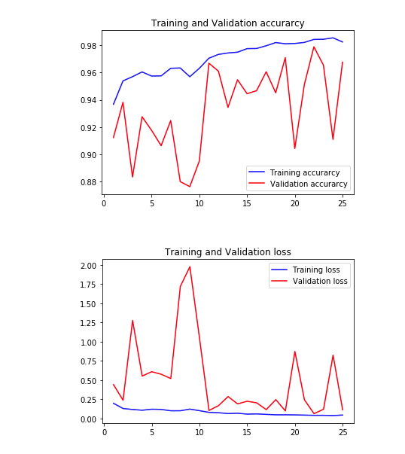

Figure :Training validation accuracy and loss of Oluwafemi Tairu

He used about 200 images for each class and got model accuracy of 96.77 %.

There was a study on currency recognition system [11] in Department of Computer Science and Engineering at National Institute of Technology Karnataka of Surathkal, India. The used Identification using empty regions (in the center, left, or right portions of the note) approach to classify the items. Harald Scheidl built a model to build a Handwritten Text Recognition System using TensorFlow. [12] In this neural network project, he created The NN consists of 5 CNN and 2 RNN layers and outputs a character-probability matrix in this project. There was a study on Using Deep Learning and CNNs to make a Hand Gesture recognition model [13]. He used 1000 different image of 10 hand gestures. He got 99.98% test accuracy.

1. DATA DESCRIPTION

Insert Data description here

1. Methodology

Insert methodology here

1. conclusion

insert conclusion here..

References

|  |  |
| --- | --- |
| [1] | I. Goodfellow, Y. Bengio and A. Courville, " Deep Learning," *MIT Press,* p. 326, 2016. |
| [2] | V. d. Oord, Aaron, Dieleman, Sander, Schrauwen, Benjamin, C. J. C. Burges, L. Bottou, M. Welling, Z. Ghahramani and K. Q. Weinberger, "Deep content-based music recommendation Curran Associates,," p. 2643–2651., 2013. |
| [3] | R. Collobert and J. Weston, "A Unified Architecture for Natural Language Processing: Deep Neural Networks with Multitask Learning. Proceedings of the 25th International Conference on Machine Learning. .," *ICML 08,* Vols. New York, NY, USA: ACM., 2008. |
| [4] | K. Fukushima, ""Neocognitron". Scholarpedia. .," *doi:10.4249/scholarpedia..,* vol. 2(1), p. 1717, 2007. |
| [5] | D. H. Hubel and T. N. Wiesel, "Receptive fields and functional architecture of monkey striate cortex," *The Journal of Physiology,* vol. 195 (1), p. 215–243. |
| [6] | Fukushima and Kunihiko, "Neocognitron: A Self-organizing Neural Network Model for a Mechanism of Pattern Recognition Unaffected by Shift in Position," *Biological Cybernetics.,* vol. 36 (4), pp. 193-202, 2013. |
| [7] | M. Matusugu, K. Mori, Y. Mitari and Y. Kaneda, "Subject independent facial expression recognition with robust face detection using a convolutional neural network" (PDF). Neural Networks. : .," *doi:10.1016/S0893-6080(03)0,* vol. 16(5), p. 555–559. |
| [8] | "CS231n Convolutional Neural Networks for Visual Recognition. .," *cs231n.github.io,* Retrieved 2018-12-13.. |
| [9] | Habibi, Aghdam, Hamed and E. J. Heravi, Guide to convolutional neural networks : a practical application to traffic-sign detection and classification., Cham, Switzerland.. |
| [10] | Oluwafemi Tairu, "plant-ai-plant-disease-detection-using-convolutional-neural-network-," 2018. |
| [11] | V. Abburu, S. Gupta, S. R. Rimitha, M. Mulimani and S. G. Koolagudi, "Currency Recognition System Using Image," *IEEE,* 2017. |
| [12] | H. Scheidl, "Build a Handwritten Text Recognition System using TensorFlow," Jun 15, 2018. |
| [13] | F. Borba, "Using Deep Learning and CNNs to make a Hand Gesture recognition model," 2019. |

Authors

**First Author** – Iftekhar Jamil, mail: bsse0802@iit.du.ac.bd

**Second Author** – Ibrahim Khalil, mail: bsse0804@iit.du.ac.bd.

**Third Author** – Tulshi Chandra Das, mail: bsse0811@iit.du.ac.bd